Jessica Miron
BME 598: Applied Programming
Homework 12

Executive Summary
Tuberculosis, or TB, is a deadly disease that poses a great public health challenge especially when it comes to diagnosis. Building a classifier that is able to differentiate between TB and non-TB patients (both healthy and differential diagnoses) from whole blood would enable greater treatment due to improved diagnosis. From the limited dataset of whole-blood genome-wide transcriptional profiles of patients with TB, active sarcoid, non-active sarcoidosis, and no disease, a beginning classifier was created but overfitting was a problem. The analysis seeks to fix the overfitting of the model and obtain both a loss and validation loss less than 0.01. The steps to do this are shown below.
- Download the dataset and Python packages
- Select out only the disease states being evaluated
- Select only the values of the genes
- Select the top 1000 genes with the greatest variance
- Scale the full dataset based on the combined training and validation sets
- Map the labels to 0 for TB and 1 for every other disease state
- Model

Biological Interpretation
The beginning classifier is a multiclass classifier which overfits the data. The model classifies into four categories using two dense layers and two dropout layers. The first dense layer has 600 neurons, the first dropout layer has a rate of 0.3, the second dense layer has 200 neurons, and the second dropout layer has a rate of 0.2. After training the model with 100 epochs, an accuracy of 0.9701, loss of 0.1969, validation accuracy of 0.8333, and a validation loss of 0.4453 were obtained. The loss and accuracy per epoch graphs are shown in figure 1. The classifier is over fitting the model due to the loss and accuracy continuing to improve while the validation loss and validation accuracy stagnant or get worse. On the loss versus epoch graph, the training loss continues to decrease across epochs reaching below 0.2 while the validation loss plateaus at 20 epochs and remains around 0.5. A well-fit model should have the validation loss and accuracy continue to improve in line with the training loss and accuracy.
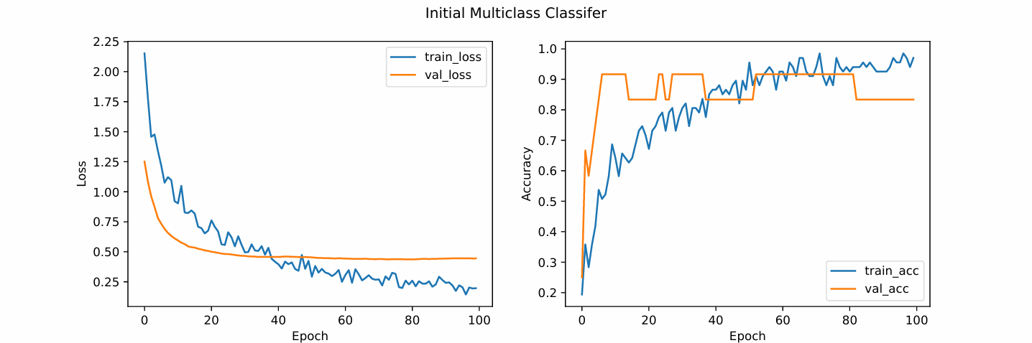
Figure 1: Loss vs epoch and accuracy vs epoch for the initial multiclass classifier. Training metrics are shown in blue. Validation metrics are shown in orange. The graphs show the model is overfitting the data due to the validation loss and accuracy stagnating and getting worse while the training loss and accuracy continue to improve.
To correct the overfitting, two strategies are used. First, changing from a multiclass to a binary classifier. Due to the limited amount of data, the multiclass classifier is attempting to create too many categories from too few datapoints causing it to just learn the individual datapoints instead of patterns across points. By changing to a binary classifier, there will be more data in the non-TB category giving a better chance of correctly classifying. Second, adding the validation data set to the training set to create a larger data set. Since the model doesn’t have enough data and learns each datapoint, by increasing the amount of data should help to reduce overfitting.
To implement these changes, a few changes were made. First, the labels were changed from one-hot encoded to 0 for non-TB and 1 for TB. Next, the last dense layer was changed from 4 to 1 neurons and from sigmoid to softmax activation. In the compiler the loss function was changed from categorical_crossentropy to binary_crossentropy. The last change was running 3500 epochs which was chosen from running the model multiple times while tuning and finding the number of epochs where the loss and validation loss stopped improving.
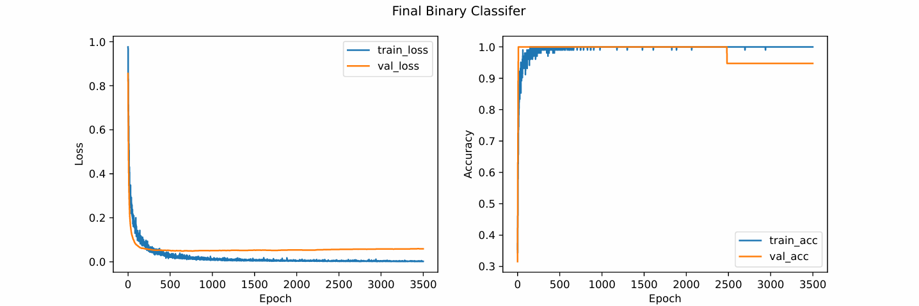
  - How did you have to modify the code to affect a change in your analysis?
    - Which specific parts of the model, optimizing, or other parts of the analysis were modified to affect your changes to improve classifier performance? Be specific.
  - What were the results of your analysis?
    - Prove that your corrections fixed the overfitting using a plot(s) and statistics.
  - Reflect on what alternative approaches could have been developed if you could have generated more data.
    - What type of data?
    - Should the study be structured differently?
- Please embed at least three figures and or tables to reinforce your interpretation. More are welcome if they help support your analyses.
  - Ensure each figure is properly labeled and includes a legend, if necessary.
  - Use data to make your points.
- Add useful citations. You must include at least three citations.

